Learning the Morse code.
By David Barlow G3PLE – PARC.
Introduction.
Learning Morse code is somewhat akin to learning a new language, perhaps more like Chinese or some other language where sound recognition is more important than the written symbol.
Having mentioned the word sound it is worth mentioning at an early stage that on the amateur bands, you will hear Morse code sent at about 800cycles per second this sort of tone level is best to listen to the Mores code from an early stage.
I learned the Morse code in the Combined Cadet Force, Signals Section and am convinced that it was taught in the wrong way – learning the alphabet Morse characters starting at A and ending at Z meant that I struggled with W, X, Y, & Z in my early teenage years. It was not until I got to Wireless Collage at Colwyn Bay that my speed and ability in Morse improved to being able to send and receive at over 30 words per minute.
At Wireless Collage during term time we stayed at benches with a Morse key at one end and heavy wires on the sides of the benches to which we attached (heavy it seems) headphones using crocodile clips. One student would send while the four or five other received articles from news papers. Each had a stint of about 5 to 10 minutes at sending; ones Morse ability son improved when this was done for at least 2 hours every day accept Sunday. Even then some found it difficult even after two years!
So PLEASE do not start learning the code from A to Z and if you have already done so and still have difficulties try a few of these suggestions given in these notes.
Enjoy Morse code it is a mode which can bring better DXCC results and introduce a greater scope to the hobby of Amateur Radio that most other modes (including digital).

The Learning Process
When we learn our native tongue, and as this is written in English the assumption will be that the reader is English, we often start with one or two syllables and our first words are often mumma or mama (interestingly enough the two dashes of the letter M) then the word “no” seems to come very easily. It is not until one learns read that the alphabet comes into prominence and is not for a year or so and then, today and on the continent, it is phonetic rather than as written. Fortunately this difference does not apply to the Morse code.
So as adults we know our alphabet and the need arises for us to apply a Morse character made up of dots (dits) and dashes (dahs) to each letter of the alphabet, but the plea has already been made not to learn it starting at A and ending at Z.
These notes contain a number of methods of learning the Morse code alphabet and a single method for numbers. Using the different methods will enable you to easily recognise the characters when you hear them. So the first thing that is needed to learn is to learn which characters Dits and Dahs (dot & dashes) go with which letters of the alphabet. Note that I have been very careful not to say learn the Morse alphabet as that would be from A through to Z method.
As you are learning avoid using Dot & Dash as the words you but use DIT’s & DAH’s instead; and try to say the dit’s quickly and the dah’s elongated to daaah’s, this emulates the code you will hear.
Perhaps if you are a passenger in a car you could practice your Morse letters by reading the letters on other car’s registration plate. (Not the numbers for now).
The David Barlow Method of learning the code below can be supplemented by using the visual diagram of the Morse code which follows it and then the dits & daaah’s chart.
As you go through the letters it helps if you listen to the sounds of each letter repeatedly by visiting www.learnmorsecode.com
There are other web sites to help you, if you do not like my method then try the others available on the web. Do not stop trying.
PLEASE IGNORE THE NUMBER FOR THE TIME BEING.
Once you are satisfied that you know the code then, and only then, move on to the next stage of these notes.
Learn the Morse code
The most common letters you will come across in plain language Morse transmission are the vowels A, E, I, O, & U,
A . - dit dah
E . dit
I . . dit dit
O - - - dah dah dah
U . . -
These are all quite short and so let us throw in perhaps the most common amateur call sing to all listening stations CQ.
C - . - . dah dit dah dit
Q - - . - dah dah dit dah
Run the CQ through your mind it is quite musical dah dit dah dit dah dah dit dah
The letter V is quite easy to remember – Beethoven’s fifth symphony (Vin Roman numerals)and the war time victory signal dit dit dit dah
V . . . - dit dit dit dah
If you get through these pages you are 30% of the way there!!!!!!!!!
Try seeing if you can form these words using the “code”
COVE QUEUE ACE VIA VOICE
Amateur radio call signs in the United Kingdom start with either a G or an M so these will come a lot:
G - - . dah dah dit
M - - dah dah
Now let us get the easily forgotten ones out of the way X, Y, & Z
X - . . - dah dit dit dah
Y - . - - dah dit dah dah
Z - - . . dah dah dit dit
Spend a bit of time on these letters as these will be the ones that will trip you up.
So now let’s go dotty E, I, S, & H (yes you have seen E & I before).
E . dit
I . . dit dit
S . . . dit dit dit
H . . . . dit dit dit dit
Now you are 57% of the way there; try using the dits and dah’s with these words
SHOE, YES, ZOO, GAZE, EXESS, HUM, SIZE, VEGE, QUAY

Dashing off
The dash letters are T, M, & O (only one new one).
T - dah
M - - dah dah
O - - - dah dah dah
But we only have a few letters left that start with a Dah (dash) in N, D, & B not forgetting K.
N - . dah dit
D - . . dah dit dit
B - . . . dah dit dit dit
K - . - dah dit dah
That takes us over three quarters of the way some more words to tap out on your desktop:-
THAT, MOVE, TAKES, US, BACK, TO, MY, EASY, GAME, NO, DOUBT.
So what’s left? They all start with Dit’s (dots). We have a single dit we have A, W, & J and with L having the extra dit.
A . - dit dah
W . - - dit dah dah
J . - - - dit dah dah dah
L can be remembered as you think of the rhythm of “ to ‘ell with it”.
L . - .. dit dah dit dit
Which leaves only R, P, & F.
P & F need intensive work as they come at the end of our learning of the Morse alphabet.
P . - - . dit dah dah dit
F . . - . dit dit dah dit
Ok so far so good? Well no not really the letter R is missing. The letter R dit dah dit in the transmitted code stands for “OK”, “all received”, “roger”, and will be heard very often over the air.
R . - . dit dah dit.
So now you have all the plain language letters. Try to get them all with the known phases:-
THE QUICK BROWN DOG JUMPS OVER THE LAZY FOX
THE FRUMP PUMPS HIS JAW LOWLY

If you have an oscillator and facilities for sending Charlie Whisky (CW) then please use them BUT it is vital that you only spend 20% of your time practicing sending and 80% receiving. The reason for this is that sending Morse is easier than receiving and if and when you use your Morse ability on air; then the experienced operator should reply to you at your send speed therefore if you transmit quicker that you can receive then you will find you cannot receive the returned Morse message.
Good luck and I do hope that you can join the other CW operators on air.
David Barlow G3PLE.

There also slow CW broadcasts of Morse to be found and details are to be found at
www.rsgb.ogr/mores/schedule.php

The code in visible form:-
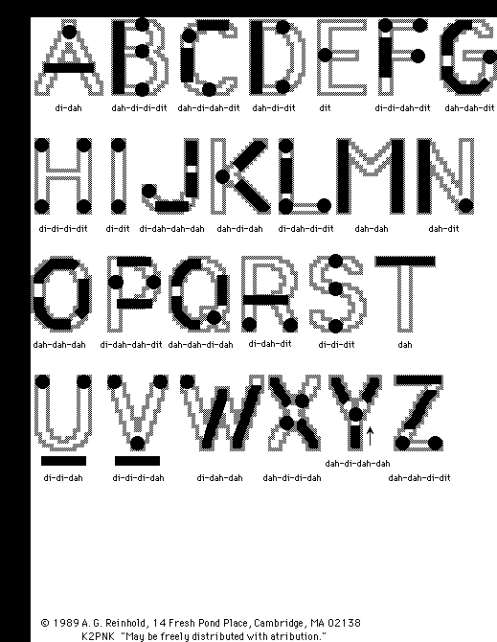
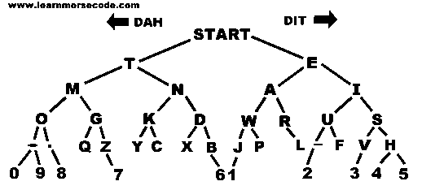
The Morse Letters: as in text group order.
A | Dit dah
E | Dit
I | Dit Dit
O | Dah Dah Dah
U | Dit Dit Dah

C | Dah Dit Dah Dit
Q | Dah Dah Dit Dah

V | Dit Dit Dit Dah

Practice Session: COVE QUEUE ACE VIA VOICE
G | Dah Dah Dit
M | Dah Dah

X | Dah Dit Dit Dah
Y | Dah Dit Dah Dah
Z | Dah Dah Dit Dit

E | Dit
I | Dit Dit
S | Dit Dit dit
H | Dit Dit Dit Dit

Practice Session : SHOE YES ZOO GAZE EXCESS HUM SIZE VEGIE QUAY

T | Dah
M | Dah Dah
O | Dah Dah Dah

N | Dah Dit
D | Dah Dit Dit
B | Dah Dit Dit Dit
K | Dah Dit Dah

Practice Session: THAT MOVE TAKES US BACK TO MY EASY GAME NO DOUBT
A | Dit Dah
W | Dit Dah Dah
J | Dit Dah Dah Dah
L | Dit Dah Dit dit

P | Dit Dah Dah Dit
F | Dit Dit Dah Dit

R | Dit Dah Dit

Also see http://www.g4fon.net/CW%20Trainer.htm

And http://www.learnmorsecode.com/

